**Agile Delivery Services BPA**

**RFQ ID: RFQ993471**

**Pool 1**

**Evidence Item No.: g**

**Usability Test Findings**

**Document Version 1.0**

**Dated 06/16/2015**

**Overview**

1. **Mission**

A usability test was initially conducted with four potential users on paper (see appendix A) to understand and identify how they would naturally want to navigate the wire frames. Afterwards, our team analyzed and evaluated this input to produce the next iterative design concept as part of the strategic plan.

The next iteration of wireframes was created and then tested online on desktop and mobile devices with seven potential users to further understand and identify how they would naturally want to navigate the wire frames. These conclusions were affirmed in the latest design and development ensued on the final design wireframes.

**Usability Test 1**

1. **Step 1**

Showing printouts with slideshow images, promo messages and action buttons – everything that appears “above the fold” on desktop and the first screen on mobile.

Question 1: Looking at the screen in front of you can you describe what this site is and how would you use it?

None of the respondents have any difficulty describing the site as:

* + - “about food safety”
    - “information on food recalls”

And

* + - “I would use it to stay informed on food recalls”
    - “I would search if my area was affected.”

Question 2: Where would you click first to start exploring the site?

All tapped “Search” button – no hesitation

1. **Step 2**

Showing printouts of the Search section.

Question 1: After landing here what would you like to search for?

* + - “If there are any recalls in my area”
    - “If Virginia is affected”
    - “Want to see all recalled products”

Question 2: Please start searching.

People are confused not finding “Search” button:

* + - “Where is Search or GO button? How do I start searching?”
    - “How do I submit? “
    - “Do I need to fill in every field?”

1. **Step 3**

Pointing to the “See search results as: Geomap OR Graph OR Timeline” section.

Question 1: Select how would you like to see your search results?

* + - “First I want to see a list with results and then decide if I want to see that list as map/graph/timeline”
    - “I would like to see them as a table. And I want them to be sortable.”
    - “Where is a List? Can I see the results as a list?”
    - One person chose GeoMap

1. **Step 4**

Showing printouts of the Geomap.

Question 1: How do you use the map for search results?

* + - "Why would I see the entire U.S. if I only search for recalls in Virginia?"
    - "Shouldn't the state(s) I searched be called out, maybe larger than the rest or outlined differently?"

Question 2: How would you then see your detailed search results?

* + - "After hovering over the state and seeing the total recalls, I should be able to click on it and be brought to a more detailed search result page. Maybe like a table."

1. **Conclusions**
   * Potential users find the need for a "Search Now" or "Submit" button when searching all recalls
   * Need to show results as a table first, not as a GeoMap or other infographic as it is not the most helpful for the user groups

**Usability Test 2**

1. **Survey Results**

Desktop

|  |  |
| --- | --- |
| Candidate A | Female |
| Candidate B | Female |
| Candidate C | Male |

Mobile

|  |  |
| --- | --- |
| Candidate D | Female |
| Candidate E | Male |
| Candidate F | Male |
| Candidate G | Male |

### 2.1 Desktop Results

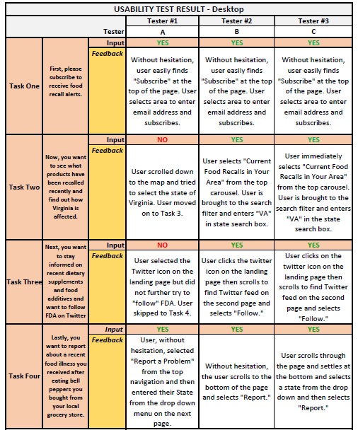

### 2.2 Mobile Results

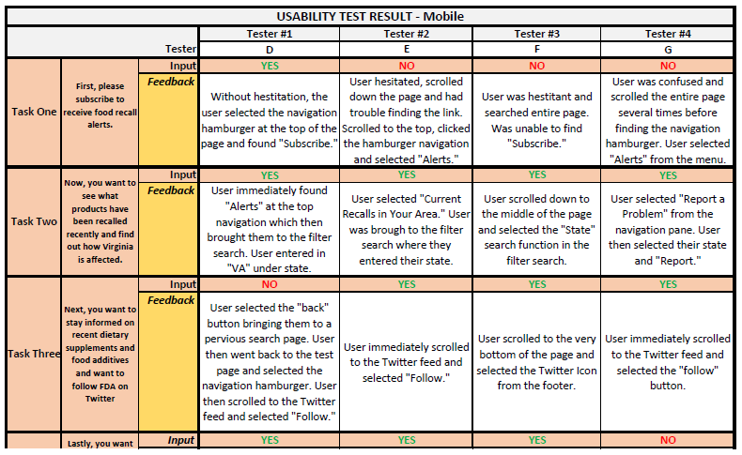

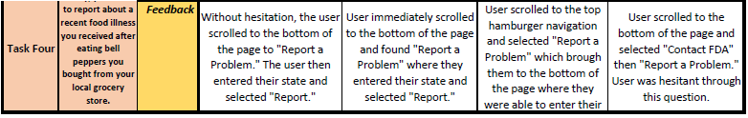

**Apendix A**

